Olitech EasyTel 4G Desktop Mobile Phone

Type of device: Mobile
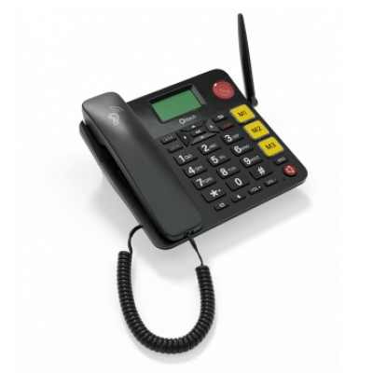

Actual Display Size : 2.4 inches
Button Type : Physical Keypad
Network Capability : 3G,4G
Year of Release : 2022
Average Price : $189 as of 18 08 2022

Accessibility Features:

Hearing Impairment and Deaf
- Bluetooth or Wi-Fi
- Hearing Aid Microphone Coupling
Hearing Aid Telecoil Coupling

Vision
- Bluetooth or Wi-Fi
- Key Numbers - Standard Layout
- Key Press - Vibration or Click
Voiced Menus

Speech
- Bluetooth or Wi-Fi
Voice amplification

Physical
- Bluetooth or Wi-Fi
- Flat Back for Table Top Operation
- Physical Dialling Keys
Speaker-phone option

How and where to get it from?
You can buy this phone from Vision Australia, Olitech, and other retailers.

More information is available on:
Olitech EasyTel 4G Desktop Mobile Phone PDF User Manual Website
Olitech EasyTel 4G Desktop Mobile Phone Instructional Videos Website

